Chapter 13, Solution 11.

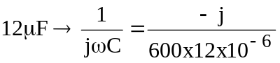 = –j138.89

After transforming the current source to a voltage source, we get the circuit shown below.

-j138.89
I_{x}
200
•
800 ∠ 0°
I₁
j480
+
_
+
_
110 ∠ 30°
150
•
I₂
j360
j720

For mesh 1,
or
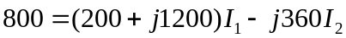 (1)

For mesh 2,
110∠30˚ + 150–j138.89+j720)I₂ + j360I₁ = 0 or
(2)

In matrix form,
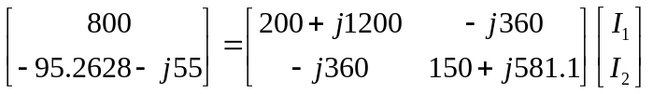
Solving this using MATLAB leads to:

>> Z = [(200+1200i),-360i;-360i,(150+581.1i)]
Z =
1.0e+003 *
0.2000 + 1.2000i 0 - 0.3600i
0 - 0.3600i 0.1500 + 0.5811i
>> V = [800;(-95.26-55i)]
V =
1.0e+002 *
8.0000
-0.9526 - 0.5500i
>> I = inv(Z)*V
I =
0.1390 - 0.7242i
0.0609 - 0.2690i

I_{x} = I₁ – I₂ = 0.0781 – j0.4552 = 0.4619∠–80.26˚.

Hence,

i_{x}(t) = 461.9cos(600t–80.26˚) mA.

